**COVID-19 VACCINE ANALYSIS**

Phase 3: Development



**DESCRIPTION:**

The project involves analyzing COVID-19 data to gain insights into the impact of vaccination campaigns on public health. We aim to understand vaccination rates, vaccine efficacy, and the relationship between vaccination and the spread of COVID-19.

**DATASET AND ITS DETAIL (**[**WWW.KAGGLE.COM/DATA**](http://WWW.KAGGLE.COM/DATA)**):**

The dataset was obtained from Kaggle, a well-known data science and machine learning platform. It provides a comprehensive COVID-19 dataset with information on cases, vaccinations, demographics, and other related variables.

LINK: https://www.kaggle.com/datasets/swatikhedekar/state-wise-india-covid19vaccination

**GIVEN DATA SET:**

The dataset "State-wise India COVID-19 Vaccination" on Kaggle provides detailed information about the COVID-19 vaccination efforts in different states of India. It includes data related to the administration of COVID-19 vaccines, the type of vaccines used, and the number of individuals vaccinated.

|  |  |  |  |  |
| --- | --- | --- | --- | --- |
| **State/UTs** | **Total Vaccination Doses** | **Dose 1** | **Dose 2** | **Population** |
| Andaman and Nicobar | 629054 | 311893 | 317161 | 399001 |
| Andhra Pradesh | 84147957 | 40624263 | 43523694 | 91702478 |
| Arunachal Pradesh | 1596166 | 856732 | 739434 | 1711947 |
| Assam | 42998698 | 22535419 | 20463279 | 35998752 |
| Bihar | 119963226 | 62590002 | 57373224 | 128500364 |
| Chandigarh | 2001114 | 1088086 | 913028 | 1158040 |
| Chhattisgarh | 36927545 | 18855121 | 18072424 | 32199722 |
| Dadra and Nagar Haveli and Daman and Diu | 1319914 | 729023 | 590891 | 773997 |
| Delhi | 30710281 | 16555043 | 14155238 | 19301096 |
| Goa | 2572559 | 1353009 | 1219550 | 1521992 |
| Gujarat | 98534412 | 49269034 | 49265378 | 70400153 |
| Haryana | 40581317 | 21938012 | 18643305 | 28900667 |
| Himachal Pradesh | 11770370 | 6028184 | 5742186 | 7503010 |
| Jammu and Kashmir | 20272520 | 9936338 | 10336182 | 14999397 |
| Jharkhand | 36992685 | 21243308 | 15749377 | 40100376 |
| Karnataka | 100209012 | 49971474 | 50237538 | 69599762 |
| Kerala | 50729256 | 26999013 | 23730243 | 34698876 |
| Ladakh | 404656 | 219238 | 185418 | 290492 |
| Lakshadweep | 112378 | 56831 | 55547 | 66001 |
| Madhya Pradesh | 107931053 | 54060775 | 53870278 | 85002417 |
| Maharashtra | 155773246 | 84570317 | 71202929 | 124904071 |
| Manipur | 2666749 | 1457120 | 1209629 | 3436948 |
| Meghalaya | 2348527 | 1329229 | 1019298 | 3772103 |
| Mizoram | 1440084 | 783477 | 656607 | 1308967 |
| Nagaland | 1515042 | 835771 | 679271 | 2073074 |
| Odisha | 60803739 | 31331147 | 29472592 | 47099270 |
| Puducherry | 1620765 | 903986 | 716779 | 1646050 |
| Punjab | 41717794 | 22309609 | 19408185 | 30501026 |
| Rajasthan | 97164120 | 51029686 | 46134434 | 79502477 |
| Sikkim | 1045753 | 539208 | 506545 | 658019 |
| Tamil Nadu | 107856629 | 56110543 | 51746086 | 83697770 |
| Telangana | 58332610 | 29547155 | 28785455 | 38157311 |
| Tripura | 4962881 | 2653391 | 2309490 | 4184959 |
| Uttar Pradesh | 299773777 | 153669397 | 146104380 | 231502578 |
| Uttarakhand | 16068172 | 8164652 | 7903520 | 11700099 |
| West Bengal | 128418265 | 67232447 | 61185818 | 100896618 |

**Tasks Completed:**

With this dataset, I have developed code using the Python programming language. In this phase, I have performed the following actions:

1. **List Files in Current Directory**: List Files in Current Directory is a concise and appropriate title for this code snippet. It accurately describes the main action being performed in the code, which is using the **ls** shell command to list the files in the current directory.
2. **Viewing the First Rows of a DataFrame:** It serves the purpose of displaying the first few rows of a DataFrame for quick inspection and understanding of the dataset.
3. **Calculation of Mean:** I calculated the mean (average) value for a specific variable within the dataset to understand the central tendency of that variable.
4. **Minimum Members Vaccinated:** I identified the state or union territory with the lowest number of members vaccinated and reported the corresponding vaccination figure.
5. **Maximum Members Vaccinated:** Similarly, I identified the state or union territory with the highest number of members vaccinated and reported the associated vaccination count.

These actions provide a foundational understanding of the dataset and facilitate the exploration and interpretation of key statistics related to COVID-19 vaccination across different regions.

**List Files in Current Directory:**

import pandas as pd

!ls

COVID-india-statewise.csv sample_data

**Explanation:**

1. **import pandas as pd**: This line imports the Pandas library and assigns it the alias 'pd.' Pandas is a powerful data manipulation library used for working with structured data, particularly in tabular form (like spreadsheets). By aliasing it as 'pd,' you can use 'pd' as a shorthand to access Pandas functions in your code.
2. **!ls**: This is not a Python command but a shell command (commonly used in Unix/Linux-based systems). It's used to list the files and directories in the current directory. In a Jupyter Notebook or IPython environment, you can use **!** to run shell commands from within your Python environment.

**Viewing the First Rows of a DataFrame**:

df.head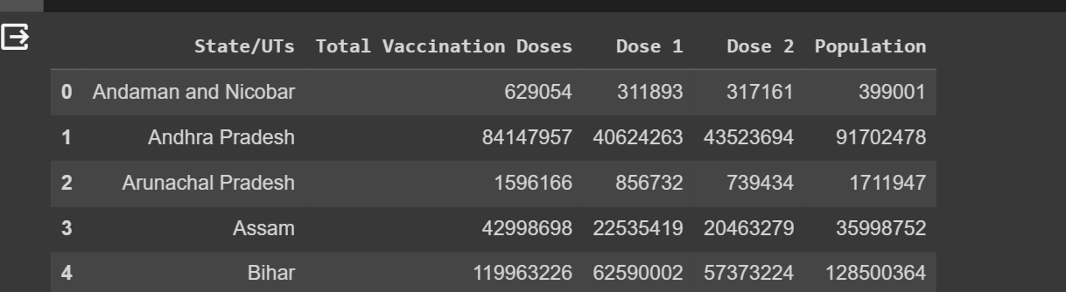

**Calculation of Mean:**

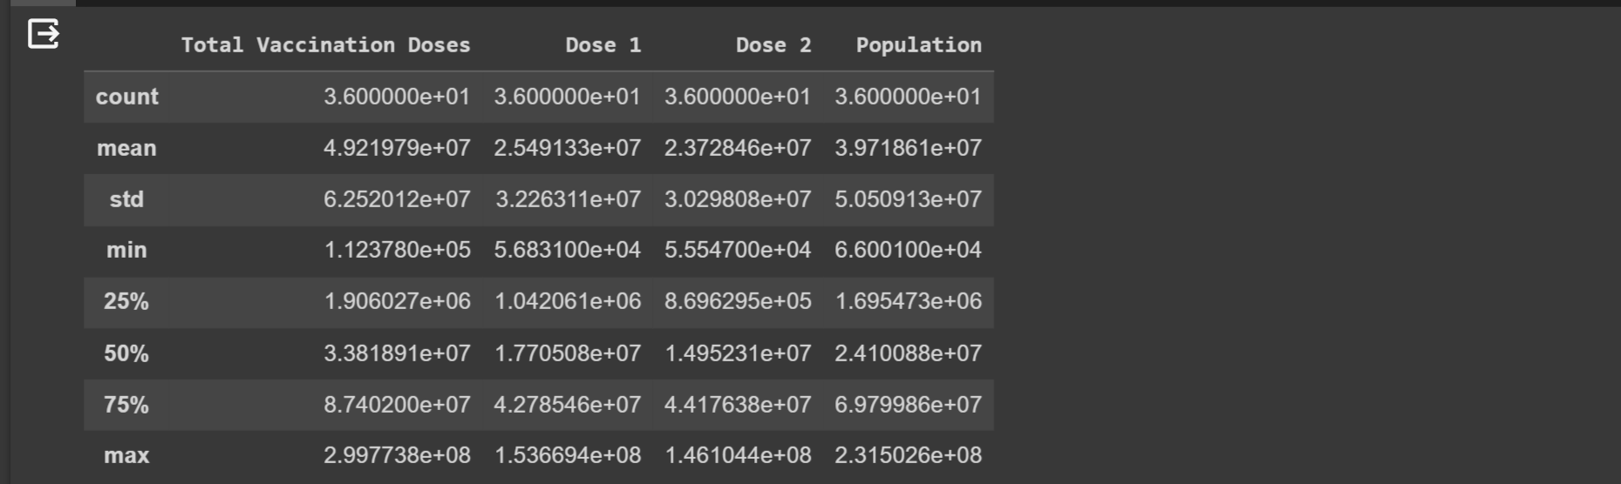df.describe()

Graphs:

**Distributions**

**2-d distributions:**

**Values :**

**Minimum Members Vaccinated:**

df.min()

**Maximum Members Vaccinated:**

df.max()

**CONCLUSION:**

In conclusion, the analysis of the 'State-wise India COVID-19 Vaccination' dataset provided valuable insights into the vaccination efforts across different states and union territories in India. Key statistics, including the mean number of vaccination doses administered, the total count of records, and the states with the minimum and maximum members vaccinated, were calculated.These statistics shed light on the variation in vaccination coverage across regions, offering essential information for assessing and planning public health strategies. This initial analysis serves as a foundational step for further in-depth exploration and data-driven decision-making in the fight against COVID-19."

**Top of Form**

**Akalya. M**

**Nandha college of technology**

**18.10.23**